Delayed seed germination correlates with low disturbance and is indifferent to stress

Introduction
Developmental delay is a condition in which physiological development is arrested even thou the environment is favorable for development (Tuljapurkar 1990; Tuljapurkar & Wiener 2000). Developmental delay often results in slower growth rates and ultimately in a reproduction delay. This is important because early development and rapid reproduction should be, in theory, associated with high individual fitness and thus favored by fecundity selection (Donohue et al. 2010; Scott & Otto 2014). Even so, developmental delay is common in many species across the tree of life (Tuljapurkar 1990; Tuljapurkar & Wiener 2000). A widespread example of developmental delay is delayed seed germination, i.e. the fact that a seed may not germinate even if exposed to favorable moisture and temperature conditions suitable for seedling establishment and survival [@RN5408] (REF). Delayed germination can be the consequence of two factors: inherent seed dormancy and environmentally-imposed delayed germination (Lamont & Pausas 2023). Inherent seed dormancy is a state in which physicochemical properties of the seed prevent progress towards germination even if external conditions are otherwise suitable (Finch-Savage & Leubner-Metzger 2006; Baskin & Baskin 2014). Environmentally-imposed delayed germination is a response to external environmental cues that must be replaced by suitable cues for germination to start (i.e. imposed dormancy sensu Lamont and Pausas (2023)); this includes signals such as specific levels and combinations of moisture, temperature, light and chemicals (Bewley et al. 2013). These two factors (inherent and imposed) have been the subject of a long terminological debate in plant ecology and physiology (Vleeshouwers et al. 1995) despite the fact that both of them are aspects of the same phenomenon: delayed seed germination. ...What is important is to focus on the fact that, in many plant species, the set of conditions that allow germination (i.e. the seed germination niche) is narrower than the set of conditions that would allow seedling survival and growth. In other words, the seeds of many species are programmed to not germinate under many scenarios, i.e. delayed germination is widespread in the world’s flora (Baskin & Baskin 2014; Lamont & Pausas 2023), even if less dormant and earlier germinating seed populations should produce more offspring and of a larger size within each year’s reproductive cycle (Pincheira-Donoso & Hunt 2017).
Delayed germination has traditionally been understood as a multi-scale regulation of germination phenology, integrating environmental cues from long-term seasonal variation (e.g. physiological dormancy release by overwintering) with short-term and microhabitat cues (e.g. light changes in the soil depth profile) (Finch-Savage & Leubner-Metzger 2006) to ensure that seed germinate at the right time and in the right place to maximize the probability of subsequent seedling survival and growth (Donohue et al. 2010). Importantly, delayed germination is only adaptive if there are heterogeneous/different regeneration environments with different odds of seedling survival and growth, and delayed-germination cues allow to differentiate between regeneration environments (Pausas et al. 2022). If the occurrence of favorable regeneration environments is unpredictable (e.g. erratic rain events in a desert), the bet-hedging hypothesis poses that delayed germination of part of a seed population can act to distribute germination events across different times, to increase the chance that at least part of the seed population will germinate during a favorable time (Venable & Brown 1988; Gremer & Venable 2014). Alternatively, if the occurrence of favorable regeneration environments occurs regularly (e.g. snowmelt in an alpine snowbed), the best-bet hypothesis proposes that seeds have specific germination requirements that track predictable environmental changes, and therefore concentrate their germination in the most favorable regeneration window. The term ‘best-bet hypothesis’ was recently coined by Pausas et al. (2022), but its underlying logic has had a long tradition in seed ecology, for example, in the interpretation by Baskin and Baskin (1976) of the different germination strategies of winter vs. summer annuals. Contrary to the view of Lamont and Pausas (2023), this type of delayed germination can be a response to predictable intra-annual seasonality. In the winter annual example, individuals shed their mature seeds in spring, but these seeds delay their germination until autumn, so seedlings avoid predictable drought during summer (Baskin & Baskin 1976). In this particular case, delayed germination is achieved by a requirement for summer after-ripening to overcome physiological seed dormancy (Baskin & Baskin 1976), and this trait is understood to be essential for the winter annual life cycle in temperate seasonal environments (Footitt et al. 2014Footitt et al. 2014).
To date, the patterns of delayed germination have been studied using macroclimate as a surrogate for regeneration environment favorability (Rubio de Casas et al. 2017; Carta et al. 2022; Zhang et al. 2022; Rosbakh et al. 2023). These efforts have served to test and validate many aspects of the best-bet hypothesis as formulated in biogeographical seed ecology (Baskin & Baskin 1976). However, as pointed out recently (Pausas et al. 2022; Lamont & Pausas 2023), a needed next step is to go beyond macroclimate and focus on the other aspects of the regeneration environment that determine its suitability and its relation to delayed seed germination. The favorability of regeneration environments can be conceptualized in terms of stress and disturbance , the major drivers of plant life histories (Grime 1979). Environmental stress during regeneration has been described as the existence of a bad season for germination and seedling establishment, and has usually been linked to the two major challenges of plant life, frost and drought (Jurado & Flores 2005), that have a close association with macroclimatic conditions. Plants adapted to frost- or drought-limited ecosystems should have germination traits that ensure delayed germination during the cold or dry season (Jurado & Flores 2005; Baskin & Baskin 2014). Some examples of this include alpine plants having physiologically-dormant seeds, preventing germination during autumn and winter (Fernández-Pascual et al. 2021); or Mediterranean species having cold-cued germination, preventing germination during the summer dry season (Doussi & Thanos 2002). Independent from stress, disturbance has been defined as a measurable loss of biomass in a biological community (Grime 1979; White & Jentsch 2001). The relationship of disturbance with delayed germination has been particularly extensively studied in fire-prone ecosystems (Baker et al. 2005; Dairel & Fidelis 2020). Fire can act both as a cue for dormancy release (smoke, heat) and as a creator for optimal regeneration conditions (low competition, high resource availability, low predation, low pathogen load) (Pausas et al. 2022). Therefore, fire-cued germination delay is expected to be advantageous when fire intervals are shorter than the lifespan of the dominant competitor species, and when they are sufficiently frequent and predicted to occur within the interval between plant maturation and senescence (Keeley et al. 2011; Pausas & Keeley 2014). However, ecological theory (Macarthur 1962; MacArthur & Wilson 1967) also predicts that highly disturbed environments should select for short-lived annual plants producing many small seeds, with high capacity for dispersal in space (Venable & Brown 1988). Given the trade-off between seed dispersal in space and seed dispersal in time via delayed germination (Chen et al. 2020), we could expect that highly disturbed environments would correlate with low seed dormancy (i.e. low germination delay), as plants would escape from high disturbance by producing many cheap and highly dispersible seeds with high germinability, to maximize the chance of germinating in a place with a favorable situation along the disturbance cycle.
Here we have studied the macroecological patterns of seed germination delay in response to the underlying drivers of regeneration environment suitability: stress and disturbance. We have done so by performing a meta-analysis of primary germination records using a large dataset representing > 17,000 records of > 1,300 species from 97 botanical families of the European flowering plants. Rather than measuring delayed germination as the presence/absence of seed dormancy (Rubio de Casas et al. 2017; Zhang et al. 2022; Rosbakh et al. 2023), our meta-analysis has considered the multi-faceted responses of seed germination to various cues including scarification, cold stratification, temperature regimes and light (Carta et al. 2022). Based fundamentally on the best-bet hypothesis, we have tested the following predictions:
(1) delayed seed germination should correlate with species adapted to high stress and low disturbance;
(2) the specific germination cues driving delayed seed germination should vary depending on the species preferences for stress and disturbance. Specifically, ...

Methods

Seed germination dataset
We obtained a curated pan-European seed germination dataset by retrieving records from SeedArc, the global archive of primary seed germination data (Fernández-Pascual et al. 2023). We define a record as a germination proportion of a given seed lot of a species, recorded in response to a given set of germination cues recreated in laboratory experimental conditions. To ensure data quality, we only retrieved records belonging to (1) angiosperms, to avoid the effect of gymnosperm branch lengths on subsequent phylogenetic analysis; (2) species present in the megatree of the seed plans by Smith & Brown (2018), a tree that would be used in subsequent analysis; (3) experiments conducted with seeds collected from wild populations in Europe, between 30º W and 70º E and north of 30º N; (4) laboratory experiments conducted with either agar or filter paper as substrate; (5) experiments not using specialized and uncommon treatments (e.g. sterilization, nitrates, plant hormones, UV light); (6) experiments not using complex dormancy breaking cycles with warm stratification or several steps (e.g. move-along experiments), which would be not comparable with simpler and more common experiments; (7) experiments conducted with at least 5 but no more than 1,000 seeds per experimental replicate; (8) species with data available for the ecological and disturbance indicator values (see below). Furthermore, to merge disparate original datasets, we simplified the germination cues by merging the originally-recorded treatment levels into simpler treatment levels that are routinely recorded and comparable across germination tests: (1) scarified vs. unscarified seeds (binary, 1/0); (2) cold-stratified vs. non-stratified seeds (binary, 1/0); (3) average germination temperature (numerical, in degrees); (4) alternating vs. constant temperatures (binary, 1/0); and (5) presence/absence of light during the experiment (binary, 1/0). These cues are proxies of underlying quantitative variables that drive the physiological responses of seeds: e.g. the cardinal germination temperatures, the red:far red ratio, the length of the photoperiod, the amplitude of the diurnal thermal oscillations, the length and temperature of cold stratification, the heat thresholds for scarification, etc. Further, to merge and homogenize this dataset with the stress-disturbance dataset (see below), we standardized all species names using the World Checklist of Vascular Plants V.10 (Govaerts et al. (2021)).

Stress and disturbance groups
We classified species in the germination dataset into four stress-disturbance groups: low stress - low disturbance, high stress - low disturbance, low stress - high disturbance and high stress - high disturbance. To perform this classification, we used the species’ ecological indicator values (EIVs) for temperature, moisture, disturbance frequency and disturbance severity. EIVs are a numerical ordering of species according to their optima along environmental gradients. For temperature and moisture, we compared the EIVs provided by Dengler et al. (2023) and Tichý et al. (2023) and verified that (1) their values were comparable and (2) the selection of one or the other did not affect subsequent analysis. Thus, we decided to use the values by Dengler et al. (2023) because they covered more of the species in the germination dataset. For the disturbance EIVs, we used the values of disturbance frequency (the mean value of the disturbance return time, in years) and disturbance severity (a proportional value, 0/1, of biomass loss in the community) provided by Midolo et al. (2023). In this case, we decided to use the version of the EIVs calculated by Midolo et al. (2023) for the herb layer, since it is in the herb layer where regeneration by seed takes place. The four EIVs were used to classify the species into the aforementioned four groups (Fig. 1). We classified a species as low stress if its EIVs for temperature and moisture were above the median value of the EIV, i.e. if the species avoided low values of temperature (a proxy of freezing stress) and water availability (a proxy of drought stress); and we classified a species as high stress if it did not meet the previous condition. Similarly, we classified a species as low disturbance if its EIVs for disturbance frequency and severity were below the median value of the EIV, i.e. if the species avoided frequent or severe disturbances; and we classified a species as high disturbance if it did not meet the previous condition. We acknowledge that this approach does not consider potential different effects of temperature vs. moisture stress, and of disturbance frequency vs. severity, but we were interested in testing the overall effect of stress and disturbance across species.

Statistical analysis
We tested the relationship between species stress-disturbance groups and delayed germination by performing a meta-analysis of the germination dataset using binomial generalized mixed models with Bayesian estimation (Markov Chain Monte Carlo generalized linear mixed models, MCMCglmms) as implemented in the R package MCMCglmm (Hadfield 2010). See Carta et al. (Carta et al. 2022) for an exhaustive description of the MCMCglmm methodology in the context of seed germination meta-analysis. In the models, the response variable was always the final germination proportion. Since the conditions in which all the germination tests had been performed were generally adequate for seedling survival and growth, we assumed that any deviation from 100% final germination represented a case of delayed germination. To test our first prediction (brief reminder here?), we fitted a model for the whole dataset, with the stress and disturbance groups as predictors. To test our second prediction (brief remind here?), we fitted separate models for subsets of the dataset representing each of the four stress-disturbance groups, with the germination cues (scarification, cold stratification, temperature, alternating temperature and light) as predictors. In all models, random effects included the source of the germination data (to account for between-study variation related to the research group or publication from which the data was extracted), the seed lot ID (to account for between-study variation related to differences in experimental setting, seed lot quality and storage conditions, etc.), species identity (to account for between-study variation related to differences between study species) and a reconstructed phylogenetic tree for the study species (to account for the effect of the shared phylogeny). To create the phylogeny, we used the R package U.PhyloMaker (Jin & Qian 2023) which contains an updated mega-tree of the seed plants based on Smith & Brown (2018). . Response variables were centered and scaled so their contribution to the effect sizes could be compared. We used weakly informative priors, with parameter-expanded priors for the random effects, (Hadfield 2010). Each model was run for 1,000,000 MCMC steps, with an initial burn-in phase of 200,000 and a thinning interval of 1,000 (De Villemereuil & Nakagawa 2014), resulting, on average, in 9,000 posterior distributions. From the resulting posterior distributions, we calculated mean parameter estimates and 95% highest posterior density and credible intervals (CI). We interpreted the significance of model parameters by examining CIs, considering parameters with CIs overlapping with zero as non-significant. We performed all data analyses with R version 4.3.1 (R Core Team 2023), using the R package ‘tidyverse’ (Wickham et al. 2019) for data processing and visualization. The original datasets, as well as R code for analysis and creation of the manuscript can be accessed at the GitHub repository https://github.com/efernandezpascual/disturbance (see Data Availability Statement).

Results

Representativeness of the germination dataset
The final germination dataset contained 17,597 experimental records obtained from 187 sources (i.e. research groups providing their primary germination data or published references from which data had been extracted). Experiments had been conducted with a total of 795,345 seeds from 5,009 seed collections originating from Europe and neighboring regions (Fig S1A). Seeds had been collected across the study area, with 41 countries represented in the dataset. The dataset included 1,357 species from 97 botanical families and 32 orders, representing the major clades of the angiosperms (Fig S1B). The dataset represented all the major European habitat types, considering both the numbers of species (Fig S1C) and the number of records (Fig S1D). The majority of species and records came from zonal and natural habitat types (i.e. forests, shrublands and grasslands). Experiments had used scarified seeds in 3,393 records (19%) and cold-stratified seeds in 3,019 records (17%). The average temperatures of the experiments ranged from 0 to 40 ºC, with an average of 18 ºC. Alternating temperatures had been used in 7,377 records (42%) and light in 16,107 records (91%).

Testing the predictions
Regarding our first prediction (Fig. 2), we found that, independently from the experimental condition, high disturbance species had significantly higher overall germination proportions (posterior mean of the effect size = 0.401, 95% credible interval = -5.859 to 3.104, pMCMC < 0.001), i.e. disturbance resulted in less delayed germination. High stress species, on the other hand, had final germination proportions that were not different from those of low stress species (posterior mean of the effect size = -0.296, 95% credible interval = 0.133 to 0.631, pMCMC = 0.080).
Regarding our second prediction (Fig. 3), we found that different stress-disturbance groups had different responses to the germination cues. Low stress-low disturbance species responded positively to cold stratification and alternating temperatures; and were indifferent to the rest of the cues. High stress - low disturbance and high stress - high disturbance species responded positively to all germination cues. Low stress - high disturbance species responded positively to scarification, average temperature, alternating temperature; negatively to light; and were indifferent to cold stratification.

Random factors and phylogenetic signal
In the full model that included the entire germination dataset (i.e. the model for the first prediction), the random factor with the strongest effect was the phylogeny (mean = 8.72, CI = 5.83 - 11.70), followed by the source of the data (mean = 2.45, CI = 1.57 - 3.35), the seed collection (mean = 2.03, CI = 1.81 - 2.23) and the species (mean = 1.31, CI = 1.00 - 1.65). The phylogenetic signal in the germination responses was relatively high (λ = 0.68, CI = 0.6 - 0.75). The models for the stress - disturbance subsets (i.e. the models for the second prediction) behaved similarly to the full model, except for the model for the low stress - low disturbance subset. In this model, the random factor with the strongest effect was the source of the data (mean = 11.08, CI = 2.12 - 21.84), followed by the phylogeny (mean = 8.86, CI = 0.0002 - 27.05), the species (mean = 8.78, CI = 0.70 - 15.86) and the seed collection (mean = 2.66, CI = 0.64 - 4.81). The phylogenetic signal was not significantly different from zero (λ = 0.55, CI = 0 - 0.88).

Discussion
...
Our results indicate that delayed seed germination correlates with low disturbance and is indifferent to stress. In ecological terms, it implies that... Thus, our results partly agree with our first prediction, as high germinability was found in high disturbance species, but no differences existed between low and high stress groups. The latter suggests that...
The alternative explanation for the lack of differences between the low and high stress groups is approach to e group together frost and drought stress. Potentially, this could be a reason for the lack of effect of high stress, as temperature and water stress could have different effects on delayed germination, and this could mask the overall effect of the high stress group. On the other hand, our results indicate that low stress - low disturbance species (i.e. species avoiding at the same time temperature stress, water stress and disturbance) had lower germinability than the high disturbance groups. Species in this group are adapted to stable and mild ecosystems (e.g. ..., ...), where competition should be high, and factors like light may become the major drivers of stress. It would seem that stable andMa competitive conditions also favor delayed seed germination, as in these conditions waiting for a favorable regeneration gap could become a priority, not because of mortality risk, but simply to have a space to regenerate into. Nonetheless, we need to consider that our study only included the angiosperms of Europe, and therefore it is missing floras adapted to truly stable and mild biomes (e.g. tropical rainforests).
Our results do not support the view that, in high-disturbance environments germination delay via seed dormancy should be expected (). Disturbance must be seen from the point of view of the seed. Being relatively small and defended, seeds are not so much affected by disturbance in the same way as adult plants do, i.e. by losing their aerial biomass or dying. For seeds, disturbance may represent an opening of seedling establishment opportunities, for example by reducing competition. In this sense, the importance of disturbance as a gap provider will depend on how well the frequency and severity of disturbance align with the life span of the seed and of its competitors (Keeley et al. 2011; Pausas & Keeley 2014). A systematic simulation of life history strategies using temperate grasslands as a model (Schippers et al. 2001) concluded that dormancy is superior to dispersal as a method for coping with disturbance. In our study we have used a wider gradient of disturbance considering a sample of the European flora from different habitats and life forms. Our evaluation concludes that, when looking at the big picture, high disturbance leads to lower delayed germination. When disturbances are sufficiently frequent or severe to provide frequent or large regeneration gaps, the production of high-germinability seeds seems to be favored, possibly as a way to occupy the more available regeneration gaps.
Our models supported the prediction that different levels of stress and disturbance favor different responses to germination cues as drivers of delayed germination and germination phenology. A positive response to scarification (i.e. a signal to remove an impermeable seed coat and physical dormancy Lamont & Pausas (2023)) was found in all cases except for the group of species adapted to low stress and low disturbance. This supports the role of physical dormancy as a way to detect and respond to disturbance events such as fire (Ooi et al. 2014; Pausas & Lamont 2022) but also to delay germination under unfavorable seasons such as summer for winter annuals (Van Assche et al. 2003; Van Assche & Vandelook 2010). On the other hand, the response to cold stratification (i.e. a signal to alleviate physiological dormancy (Finch-Savage & Leubner-Metzger 2006)) was strongest in species adapted to low stress and low disturbance, and absent from species adapted to low stress coupled with high disturbance. This suggests that in environments without a pronounced suboptimal season for seedling establishment, physiological dormancy can still be advantageous to delay germination, possibly as a way to postpone competition and wait longer for a regeneration gap to open. At the same time, a positive response to cold stratification was found in the two groups of species adapted to high stress (i.e. with a bad season for germination) agreeing with previous findings (Jurado & Flores 2005; Rubio de Casas et al. 2017; Rosbakh et al. 2023). Average germination temperature (i.e. an environmental signal of the annual temperature cycle (Rubio de Casas et al. 2017; Fernández-Pascual et al. 2021)) had a positive effect in all groups except for species adapted to low stress and low germination, i.e. species of the other three groups preferred warmer germination temperatures. Indifference to the annual temperature cycle is to be expected for species from stable ecosystems without marked bad seasons for regeneration. Finally, alternating temperatures and light had contrasting responses across groups. ... These two germination cues are usually interpreted as interchangeable, signaling factors such as burial depth, canopy closure or water table height (Thompson & Grime 1983; Pons 2000; Carta et al. 2017). The contrasting effects they showed in our study suggest that each of the two cues may have some nuanced function in determining germination phenology. For example, species adapted to low stress and low disturbance responded positively to alternating temperatures but not to light. In these environments, alternating temperatures may be a more reliable indicator of the scarce regeneration gaps, such as a forest clearing after the fall of a tree. Similarly, species adapted to low stress and high disturbance responded positively to alternating temperatures but negatively to light, perhaps because lack of light may indicate a degree of soil burial that can physically protect seeds from the disturbance. In any case, the number of experiments using darkness was not very high in our dataset, so our results for the effect of light need to be interpreted with caution.
In conclusion, this study shows that delayed seed dormancy is widespread except in high disturbance situations. In all other scenarios, delayed seed germination seems to be the norm, even in stable environments without a marked unfavorable season for seed regeneration. This highlights the potential role of competition avoidance for the development of delayed germination strategies. It also suggests that there might be habitat specific factors driving the degree of delayed seed germination, as well as an effect of plant life factors such as lifespan or size, including seed mass. In this work, we have furthered the traditional understanding that delayed seed germination is a result of unfavorable regeneration environments, by deconstructing the concept of regeneration unfavorability along axes of stress and disturbance. To concentrate on these two factors, we have left the potential effects of stress types, species traits, etc. out of focus. Future studies will need to further explore these questions, extending the analysis to non European floras, and producing curated data from macroecological experiments that carefully control for seed and adult environments, species life forms and functional traits, habitats (e.g. forests vs. shrublands vs. grasslands vs. wetlands) and separate stress factors (e.g. temperature, moisture, light, salinity). Such experiments will continue to shed light into delayed seed germination, which appears to be widespread functional feature of the seed plants.

Data availability
The original datasets, as well as R code for analysis and creation of the manuscript can be accessed at the GitHub repository https://github.com/efernandezpascual/disturbance. Upon publication, a version of record of the repository will be deposited in Zenodo.

References
Baker, K.S., Steadman, K.J., Plummer, J.A., & Dixon, K.W. 2005. Seed dormancy and germination responses of nine Australian fire ephemerals. Plant and Soil 277: 345–358.
Baskin, J.M., & Baskin, C.C. 1976. High Temperature Requirement for Afterripening in Seeds of Winter Annuals. New Phytologist 77: 619–624.
Baskin, C.C., & Baskin, J.M. 2014. Seeds. Ecology, Biogeography and Evolution of Dormancy and Germination. Second Edition. Academic Press, San Diego.
Bewley, J.D., Bradford, K., Hilhorst, H., & Nonogaki, H. 2013. Seeds: Physiology of Development, Germination and Dormancy. 3rd Edition. Springer, Berlin - Heidelberg - New York.
Carta, A., Fernández-Pascual, E., Gioria, M., Müller, J.V., Rivière, S., Rosbakh, S., Saatkamp, A., Vandelook, F., & Mattana, E. 2022. Climate shapes the seed germination niche of temperate flowering plants: a meta-analysis of European seed conservation data. Annals of Botany 129: 775–786.
Carta, A., Skourti, E., Mattana, E., Vandelook, F., & Thanos, C.A. 2017. Photoinhibition of seed germination: occurrence, ecology and phylogeny. Seed Science Research 27: 131–153.
Chen, S.-C., Poschlod, P., Antonelli, A., Liu, U., & Dickie, J.B. 2020. Trade-off between seed dispersal in space and time. Ecology Letters 23: 1635–1642.
Dairel, M., & Fidelis, A. 2020. How does fire affect germination of grasses in the Cerrado? Seed Science Research 30: 275–283.
De Villemereuil, P., & Nakagawa, S. 2014. General quantitative genetic methods for comparative biology. In Modern Phylogenetic Comparative Methods and their Application in Evolutionary Biology, pp. 287–303. Springer.
Dengler, J., Jansen, F., Chusova, O., Hüllbusch, E., Nobis, M.P., Van Meerbeek, K., Axmanová, I., Bruun, H.H., Chytrý, M., Guarino, R., Karrer, G., Moeys, K., Raus, T., Steinbauer, M.J., Tichý, L., Tyler, T., Batsatsashvili, K., Bita-Nicolae, C., Didukh, Y., Diekmann, M., Englisch, T., Fernández-Pascual, E., Frank, D., Graf, U., Hájek, M., Jelaska, S.D., Jiménez-Alfaro, B., Julve, P., Nakhutsrishvili, G., Ozinga, W.A., Ruprecht, E.-K., Šilc, U., Theurillat, J.-P., & Gillet, F. 2023. ﻿Ecological Indicator Values for Europe (EIVE) 1.0. Vegetation Classification and Survey 4:
Donohue, K., Rubio de Casas, R., Burghardt, L., Kovach, K., & Willis, C.G. 2010. Germination, postgermination adaptation, and species ecological ranges. Annual Review of Ecology, Evolution, and Systematics 41: 293–319.
Doussi, M.A., & Thanos, C.A. 2002. Ecophysiology of seed germination in Mediterranean geophytes. 1. Muscari spp. Seed Science Research 12: 193–201.
Fernández-Pascual, E., Carta, A., Mondoni, A., Cavieres, L.A., Rosbakh, S., Venn, S., Satyanti, A., Guja, L., Briceño, V.F., Vandelook, F., Mattana, E., Saatkamp, A., Bu, H.Y., Sommerville, K., Poschlod, P., Liu, K., Nicotra, A., & Jiménez-Alfaro, B. 2021. The seed germination spectrum of alpine plants: a global meta-analysis. New Phytologist 229: 3573–3586.
Fernández-Pascual, E., Carta, A., Rosbakh, S., Guja, L., Phartyal, S.S., Silveira, F.A.O., Chen, S.-C., Larson, J.E., & Jiménez-Alfaro, B. 2023. SeedArc, a global archive of primary seed germination data. New Phytologist 240: 466–470.
Finch-Savage, W.E., & Leubner-Metzger, G. 2006. Seed dormancy and the control of germination. New Phytologist 171: 501–523.
Footitt, S., Clay, H.A., Dent, K., & Finch-Savage, W.E. 2014. Environment sensing in spring-dispersed seeds of a winter annual Arabidopsis influences the regulation of dormancy to align germination potential with seasonal changes. New Phytologist 202: 929–939.
Govaerts, R., Nic Lughadha, E., Black, N., Turner, R., & Paton, A. 2021. The World Checklist of Vascular Plants, a continuously updated resource for exploring global plant diversity. Scientific Data 8: 215.
Gremer, J.R., & Venable, D.L. 2014. Bet hedging in desert winter annual plants: optimal germination strategies in a variable environment. Ecology Letters 17: 380–387.
Grime, J.P. 1979. Plant strategies and vegetation processes. John Wiley & Sons.
Hadfield, J.D. 2010. MCMC methods for multi-response generalized linear mixed models: the MCMCglmm R package. Journal of Statistical Software 33: 1–22.
Jin, Y., & Qian, H. 2023. U.PhyloMaker: An R package that can generate large phylogenetic trees for plants and animals. Plant Diversity 45: 347–352.
Jurado, E., & Flores, J. 2005. Is seed dormancy under environmental control or bound to plant traits? Journal of Vegetation Science 16: 559–564.
Keeley, J.E., Bond, W.J., Bradstock, R.A., Pausas, J.G., & Rundel, P.W. 2011. Fire in Mediterranean ecosystems: ecology, evolution and management. Cambridge University Press.
Lamont, B.B., & Pausas, J.G. 2023. Seed dormancy revisited: Dormancy-release pathways and environmental interactions. Functional Ecology 37: 1106–1125.
Macarthur, R.H. 1962. SOME GENERALIZED THEOREMS OF NATURAL SELECTION. Proc Natl Acad Sci U S A 48: 1893–7.
MacArthur, R.H., & Wilson, E.O. 1967. The theory of island biogeography. Princeton university press.
Midolo, G., Herben, T., Axmanová, I., Marcenò, C., Pätsch, R., Bruelheide, H., Karger, D.N., Aćić, S., Bergamini, A., Bergmeier, E., Biurrun, I., Bonari, G., Čarni, A., Chiarucci, A., De Sanctis, M., Demina, O., Dengler, J., Dziuba, T., Fanelli, G., Garbolino, E., Giusso del Galdo, G., Goral, F., Güler, B., Hinojos-Mendoza, G., Jansen, F., Jiménez-Alfaro, B., Lengyel, A., Lenoir, J., Pérez-Haase, A., Pielech, R., Prokhorov, V., Rašomavičius, V., Ruprecht, E., Rūsiņa, S., Šilc, U., Škvorc, Ž., Stančić, Z., Tatarenko, I., & Chytrý, M. 2023. Disturbance indicator values for European plants. Global Ecology and Biogeography 32: 24–34.
Ooi, M.K.J., Denham, A.J., Santana, V.M., & Auld, T.D. 2014. Temperature thresholds of physically dormant seeds and plant functional response to fire: variation among species and relative impact of climate change. Ecology and Evolution 4: 656–671.
Pausas, J.G., & Keeley, J.E. 2014. Evolutionary ecology of resprouting and seeding in fire-prone ecosystems. New Phytologist 204: 55–65.
Pausas, J.G., & Lamont, B.B. 2022. Fire-released seed dormancy - a global synthesis. Biological Reviews 97: 1612–1639.
Pausas, J.G., Lamont, B.B., Keeley, J.E., & Bond, W.J. 2022. Bet-hedging and best-bet strategies shape seed dormancy. New Phytologist 236: 1232–1236.
Pincheira-Donoso, D., & Hunt, J. 2017. Fecundity selection theory: concepts and evidence. Biological Reviews 92: 341–356.
Pons, T.L. 2000. Seed responses to light. In Seeds: the Ecology of Regeneration in Plant Communities, pp. 237–260.
R Core Team. 2023. R: a language and environment for statistical computing. Version 4.3.1.
Rosbakh, S., Carta, A., Fernández-Pascual, E., Phartyal, S.S., Dayrell, R.L.C., Mattana, E., Saatkamp, A., Vandelook, F., Baskin, J., & Baskin, C. 2023. Global seed dormancy patterns are driven by macroclimate but not fire regime. New Phytologist 240: 555–564.
Rubio de Casas, R., Willis, C.G., Pearse, W.D., Baskin, C.C., Baskin, J.M., & Cavender-Bares, J. 2017. Global biogeography of seed dormancy is determined by seasonality and seed size: a case study in the legumes. New Phytologist 214: 1527–1536.
Schippers, P., Groenendael, J.M. van, Vleeshouwers, L.M., & Hunt, R. 2001. Herbaceous plant strategies in disturbed habitats. Oikos 95: 198–210.
Scott, M.F., & Otto, S.P. 2014. Why wait? Three mechanisms selecting for environment-dependent developmental delays. Journal of Evolutionary Biology 27: 2219–2232.
Smith, S.A., & Brown, J.W. 2018. Constructing a broadly inclusive seed plant phylogeny. American Journal of Botany 105: 302–314.
Thompson, K., & Grime, J.P. 1983. A comparative study of germination responses to diurnally-fluctuating temperatures. Journal of Applied Ecology 20: 141–146.
Tichy, L., Axmanová, I., Dengler, J., Guarino, R., Jansen, F., Midolo, G., Nobis, M.P., Van Meerbeek, K., Acic, S., Attorre, F., Bergmeier, E., Biurrun, I., Bonari, G., Bruelheide, H., Campos, J.A., Carni, A., Chiarucci, A., Cuk, M., Custerevska, R., Didukh, Y., Díte, D., Dite, Z., Dziuba, T., Fanelli, G., Fernández-Pascual, E., Garbolino, E., Gavilán, R.G., Gégout, J.C., Graf, U., Güler, B., Hájek, M., Hennekens, S.M., Jandt, U., Jaskova, A., Jiménez-Alfaro, B., Julve, P., Kambach, S., Karger, D.N., Karrer, G., Kavgaci, A., Knollova, I., Kuzemko, A., Küzmic, F., Landucci, F., Lengyel, A., Lenoir, J., Marcenò, C., Moeslund, J.E., Novák, P., Pérez-Haase, A., Peterka, T., Pielech, R., Pignatti, A., Rasomavicius, V., Rusina, S., Saatkamp, A., Silc, U., Skvorc, Z., Theurillat, J.P., Wohlgemuth, T., & Chytry, M. 2023. Ellenberg-type indicator values for European vascular plant species. Journal of Vegetation Science 34: 13.
Tuljapurkar, S. 1990. Delayed reproduction and fitness in variable environments. Proceedings of the National Academy of Sciences 87: 1139–1143.
Tuljapurkar, S., & Wiener, P. 2000. Escape in time: stay young or age gracefully? Ecological Modelling 133: 143–159.
Van Assche, J.A., Debucquoy, K.L.A., & Rommens, W.A.F. 2003. Seasonal cycles in the germination capacity of buried seeds of some Leguminosae (Fabaceae). New Phytologist 158: 315–323.
Van Assche, J.A., & Vandelook, F.E.A. 2010. Combinational dormancy in winter annual Fabaceae. Seed Science Research 20: 237–242.
Venable, D.L., & Brown, J.S. 1988. The selective interactions of dispersal, dormancy, and seed size as adaptations for reducing risk in variable environments. The American Naturalist 131: 360–384.
Vleeshouwers, L.M., Bouwmeester, H.J., & Karssen, C.M. 1995. Redefining seed dormancy: an attempt to integrate physiology and ecology. Journal of Ecology 83: 1031–1037.
White, P.S., & Jentsch, A. 2001. The Search for Generality in Studies of Disturbance and Ecosystem Dynamics. In Esser, K., Lüttge, U., Kadereit, J.W., & Beyschlag, W. (eds.), Progress in Botany: Genetics Physiology Systematics Ecology, pp. 399–450. Springer Berlin Heidelberg, Berlin, Heidelberg.
Wickham, H., Averick, M., Bryan, J., Chang, W., McGowan, L., François, R., Grolemund, G., Hayes, A., Henry, L., & Hester, J. 2019. Welcome to the Tidyverse. Journal of Open Source Software 4: 1686.
Zhang, Y., Liu, Y., Sun, L., Baskin, C.C., Baskin, J.M., Cao, M., & Yang, J. 2022. Seed dormancy in space and time: global distribution, paleoclimatic and present climatic drivers, and evolutionary adaptations. New Phytologist 234: 1770–1781.

Figures
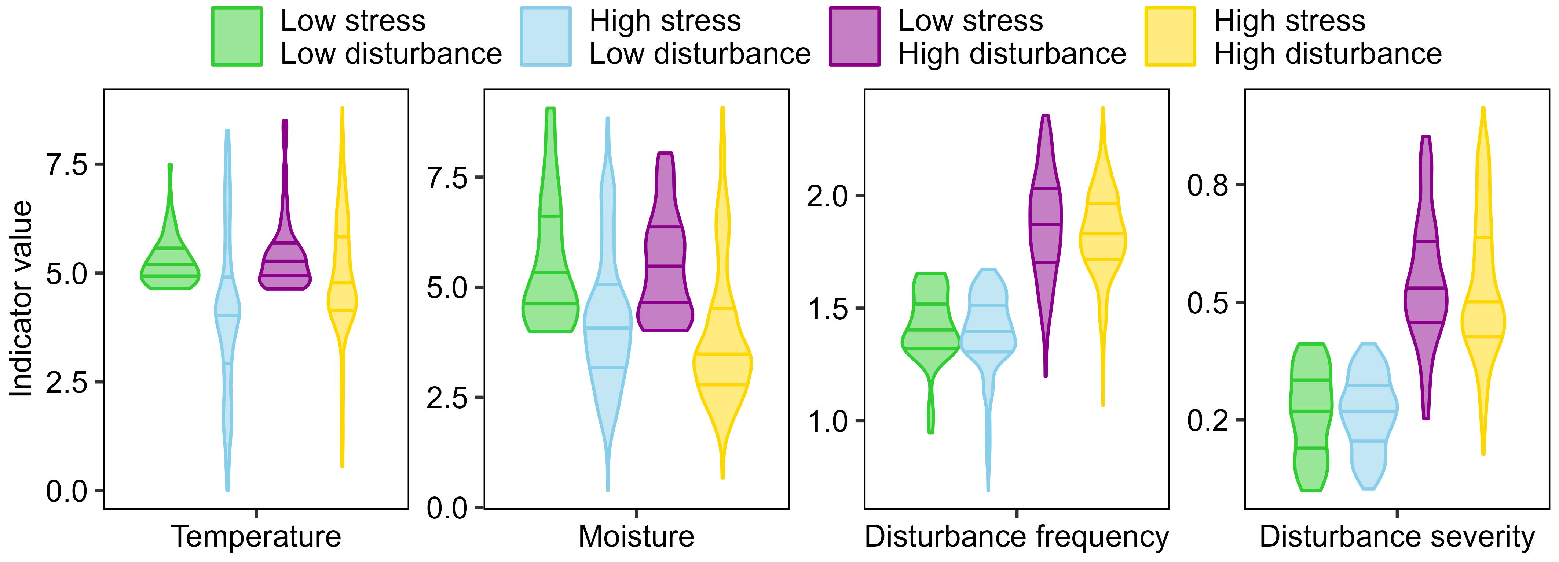
Figure 1: Stress-disturbance groups. The violin plots show the density of values for each of the four ecological indicator values (temperature, moisture, disturbance frequency and disturbance severity) in each of the four stress-disturbance groups.
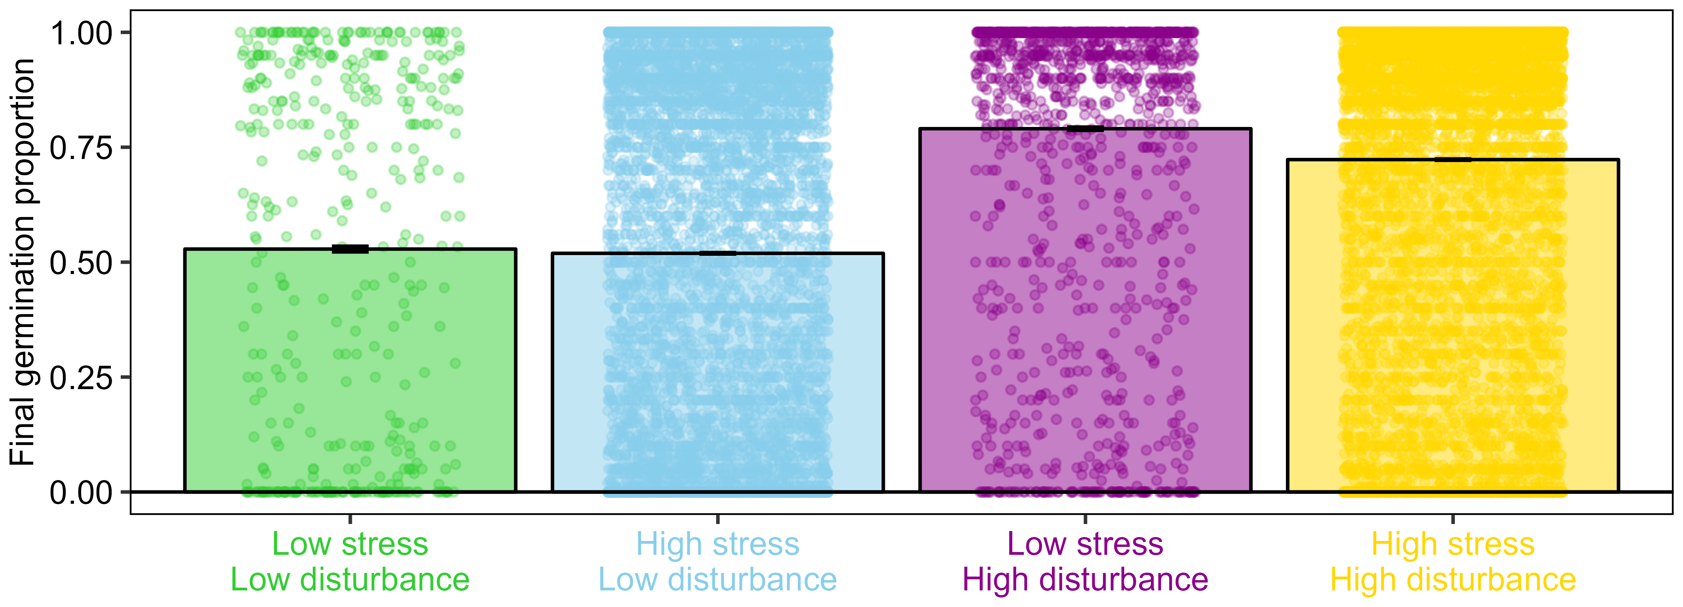
Figure 2: Seed germination of the stress-disturbance groups. The bars indicate the average final germination proportion in each of the four stress-disturbance groups, with 95% binomial confidence intervals. The dots indicate the final germination proportion in each of the original germination tests.
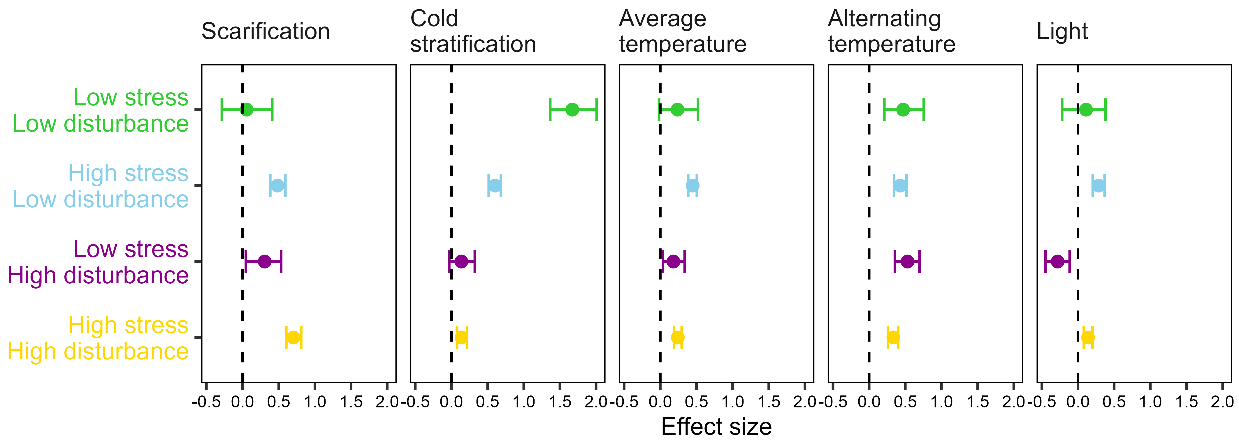
Figure 3: Germination cues in the stress-disturbance groups. Effect of germination cues (scarification, stratification, average temperature, alternating temperature and light) over the final germination proportions. Dots indicate the posterior mean of the effect size for each cue, and whiskers the 95% credible interval of the effect size. The line of zero-effect is shown: when a credible interval overlaps with the zero-effect line, the effect can be regarded as non-significant. Non-overlapping effects to the left of the zero-effect line indicate that the cue depresses seed germination, while non-overlapping effects to the left of the zero-effect line indicate that the cue promotes seed germination. In separate panels, the figure shows the effect of the germination cues in each of the four stress-disturbance models.
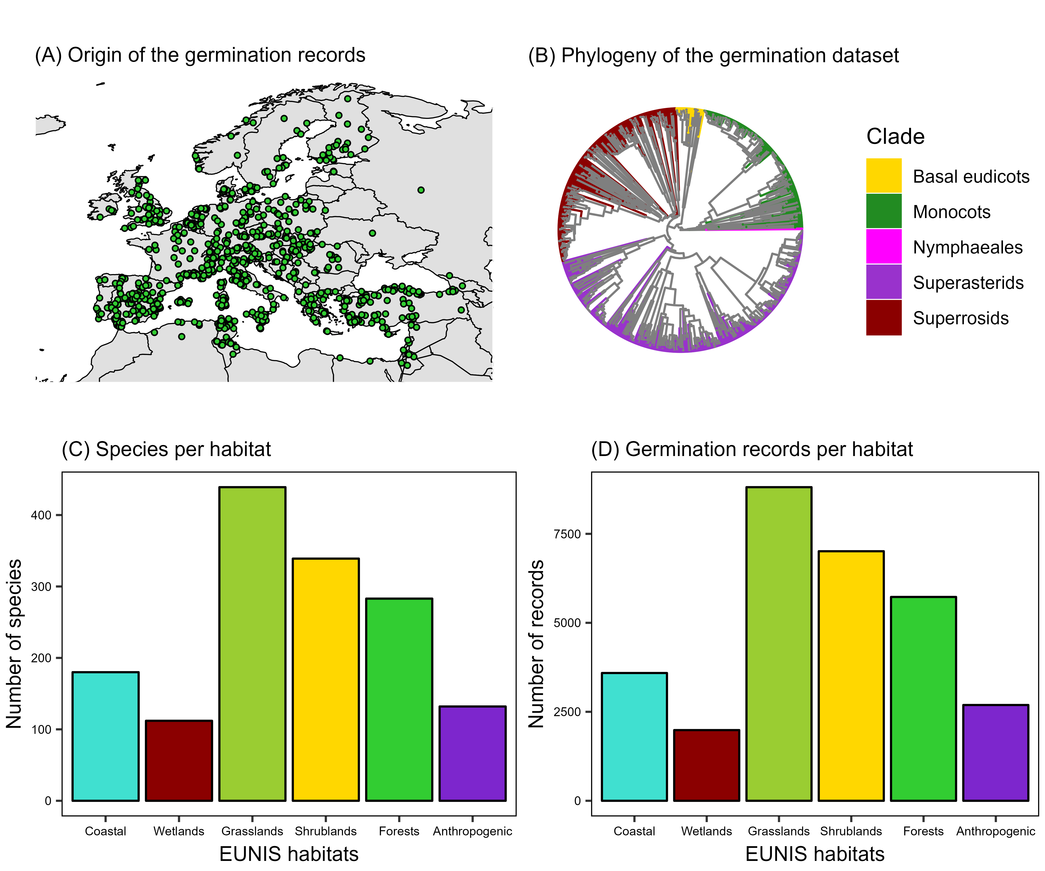
Figure 4: Supplementary FS1. Representativeness of the germination dataset. (A) Original coordinates of the seed collections used for the experiments that produced the germination dataset. (B) Phylogenetic tree of the species in the germination dataset, colored by the major clades of the angiosperms. (C) Number of species in the germination dataset that are characteristic species of the major European habitat types. (D) Number of records in the germination dataset belonging to species that are characteristic species of the major European habitat types. Habitats and characteristic species follow the EUNIS pan-European habitat classification system.

